Deep Learning Based Pothole Detection System

`

Rahul Roonwal  
B.E. Computer Science and Engineering, IV Year, Dept of CSE.  
Sathyabama Institute of Science and TechnologyChennai, India   
[roonwalrahul8@gmail.com](mailto:roonwalrahul8@gmail.com)

Rajeev Nayan   
B.E. Computer Science and Engineering, IV Year, Dept of CSE.  
Sathyabama Institute of Science and TechnologyChennai, India   
rnayan516@gmail.com

*Abstract*— India has a vast network of roads which connects the various cities and villages, due to which its maintenance becomes a challenging task and also many accidents takes place because of the damaged roads and also the accidents are increasing every year because of the increase in the number of potholes. As the inspection of these roads for damages is done manually, a significant amount of time is consumed, cost increases as it is a labor intensive process and also the possibility of human error increases. Also, as the road network is very large, it is not feasible for the Authority travel to all the places for inspection. In order to solve this problem and to increase the efficiency we can use various Image Processing techniques (such as CNN, YOLO V5) in order to find the damages and then comparing the same to find the technique with maximum accuracy. This data can further be sent to the government for repairing the roads and this helps in reducing accidents and further ensuring the safety of the citizens especially during rainy season. By using these techniques, the problem of damaged roads can be solved and also a lot of resources can be saved by repairing the roads in the right time and also by reducing the labor cost.

Keywords— PotHole, Image Processing, Deep Learning Neural Network, Convolution Neural Network Algorithm, YOLO Algorithm

# Introduction

In recent years, due to advancement in transportation, poorly maintained highways and roads results in traffic and also leads to accidents. This can be reduced by properly maintaining the roads and filling the potholes regularly which also reduces the maintenance cost. As road inspection is done manually, it becomes a time consuming job and it also requires human labour and it is also subjected to errors. Due to the damaged roads, traffic jams occur which is indirectly responsible for economic losses. Also, if these damaged roads are not repaired timely the conditions of the roads may become worse and the cost of repairing these roads also increases immensely. But it is difficult to monitor the road conditions by visiting all the roads and checking for the damages manually as it is a labor-intensive process and it also involves high inspection cost. In order the solve these problems modern techniques can be used. In the proposed system, first the images of the roads are collected after which the images are then being processed using various machine learning algorithms such as YOLO V5, CNN, etc. The dataset used in this model for the purpose training, testing and for validation is collected from various websites such as Roboflow , Kaggle ,etc .Then the dataset collected is divided into three smaller datasets in which one is used for training purpose, the other dataset is used for the purpose of testing and the third set is used after the model is trained and tested, for the purpose of validation. After the process of training, testing and validation, the algorithm with the most accuracy is used to develop an application in which the video of the road is processed and is converted into images after which the images are processed using the algorithm with the best accuracy and the potholes are found. These reports can then be sent to the concerned department to look into the matter and repairing the damaged roads thus reducing the traffic and accidents.

# Related work

This problem statement has been extensively studied over the past years by researchers in a bid to create a solution, and all their solutions vary from the algorithms used to the approaches taken for predicting the damaged roads.

The work of Mr. Anup Kumar Pandey [1] introduced a system for the detection of potholes in which the accelerometer present in the phone was used to collect the data which was further processed by training the ID-CNN model.

Deepak Kumar Dewangan [2] introduced a system for the inspection of roads and for finding the damaged roads in which a smartphone and a raspberry pi camera is used and the whole setup is placed on the vehicle and the pi camera records the road condition and then the recorded video is converted into images which is then processed and the pothole is detected using the various CNN algorithms.

Lei Chen [3] presented an image recognition system in which various techniques are used to process the given images and finding the agricultural disease using image processing. In this system, CNN model is used for detecting the agricultural disease.

Nachuan Ma [4] proposed a system for road imaging and pothole detection using various cameras , laser scanners and various other devices for road imaging which is placed on the vehicle and the images are then processed using various machine learning algorithms for pothole detection.

Ratnajit Mukherjee [5] proposed an AI based road maintenance inspection in which the images are processed for predicting the damaged roads and damaged road signs using RGPNet algorithm and then visualizing the damages on the map.

Dharneeshkar J [6] proposed a system for pothole detection which uses various image processing techniques such as YOLO v3, YOLO v2, etc and the results obtained are then compared using precision and recall for best accuracy.

Kang BH and Choi SI [7] developed a model for the detection of potholes using a 2D Lidar sensor and a Camera in which first the images are captured using a 2D Lidar sensor and the potholes are detected using various algorithms and after this step, the Camera setup is incorporated to increase its accuracy.

Kavitha R and Nivetha S [8] proposed a system for the detection of potholes which uses a Raspberry pi for recording images and then using various object detection techniques for the detection of potholes.

K. Vigneshwar, B. Hema Kumar [9] developed a system for pothole detection using various machine learning techniques such as clustering based on image segmentation and Gaussian-Filtering for the detection of potholes.

Based on the studies from the previous papers, it is noted that the pothole detection problem is solved using various algorithms and various approaches are followed but with less accuracy and only some algorithms are used in a particular approach. Also, the latest deep learning models are not used.

# Proposed Methodology

YOLO v5 and CNN are the two methods , which have been used in order to train, to test and then to validate the model for pothole detection.

The dataset used to train the YOLOv5 model, comprises of road images with labelled potholes, for each image there exists a text file which provides the annotations based on the height, width, depth and the size of the potholes in the images which then forms a boundary box around the potholes in the images, where as the dataset used in the CNN model, is divided in two categories Plain and Pothole images and it does not contain any type of predefined annotation or boundary boxes.

For YOLOv5 the dataset is imported from Roboflow website , Roboflow is a website which provide datasets in different format options available.

Then the default architecture of YOLO v5 is modified according to the model need, in our case number of classes is 1 (i.e pothole) so the nc is declared as 1 in the architecture and is saved as custom YOLO v5 model. Then, the training of custom yolov5 model is done using the imported dataset and epochs set to 280. 280 epochs are completed in 0.608 hours.

The training took almost 1 hour and the best weights are saved.

Now, the best trained weights are used for detecting the potholes in the given input images.

For CNN the dataset is downloaded from kaggle website. Here the dataset contains two categories of images i.e plain and pothole images. Data Augmentation has been performed for each of the categories using image data generator to increase the image for each of the category as because initially the dataset was balanced but was very less to be trained on.

We need to prepare data by labelling each of the images 0 - Plain and 1 - Pothole. After the preparation of data we do shuffling of data so that our model does not get overfitted and splits the data in two parts X and Y , features and target variable respectively.

The architecture of our model consists of 4 convolution layer, followed by activation “Relu” and max pooling layer with size of [2,2] respectively. At last two dense layers are added with “Relu” and “Softmax” as activation function respectively.

Then the X and Y data is splitted in train and test data (80:20) and the train data is used in the training of model.The training took around 1 hour for 150 epochs.

After the training is completed the CNN model is evaluated using the test data and the model is saved and then it can be used for detecting the potholes in the given input images.

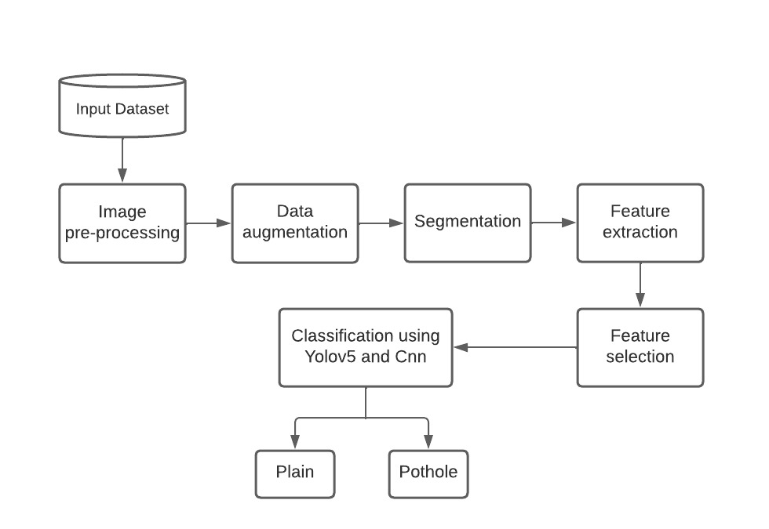

Fig. 1. Architecture Diagram of Deep Learning Model

# Dataset used

The data set is a collection of records in a particular table, each column corresponds to a particular variable in the data set, and each row corresponds to a particular record in the data set. The Record in the dataset can be of any type such as file, document, text or numerical values, etc. Since, Our Project is to detect the pothole in the road images, therefore in our case the data type in the dataset is image file of pothole and plain images. For each of the algorithm that is Yolov5 and CNN, the dataset which has been used in training of the model is not same for both the algorithm.

For Yolov5 the dataset has been imported directly from the Roboflow Website. Roboflow is a website which has a large collection of different kind of datasets. It also provides the data in different format options for various machine learning models. Therefore, Yolov5 format option has been chosen and the dataset has been imported using a code generated by a roboflow. The dataset consists of road images, for each image there exist a text file which gives the annotation based on the width, height, depth and size of potholes image that form a bounding box around the potholes in the images. The dataset consists a total of 665 images which is divided in training, validation and testing in ratio

7, 2 and 1 respectively.



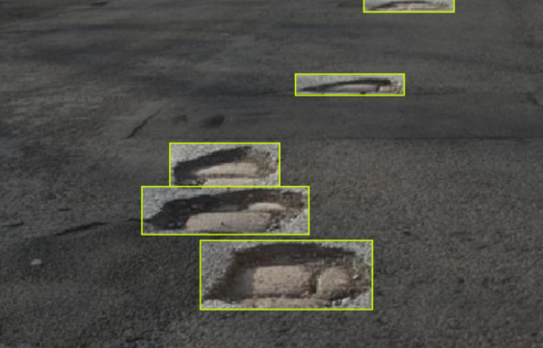

Fig. 2. Sample Dataset Image

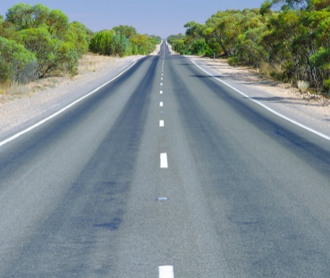For the other algorithm, which is CNN the dataset has been downloaded from Kaggle website. Kaggle is a website which provides large collection of datasets of various kinds as well as a workspace. The dataset consists of two categories of images plain and pothole images respectively. For each category the number of images used are 364 for plain images and 357 for Pothole images. The image file in the dataset does not contain any type of pre-defined annotations or bounding boxes as it was given for Yolov5.

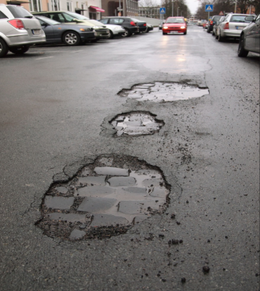

Fig. 3. Sample Dataset Image – Plain and Pothole Image

# Results And Discussion

For YOLOv5 , the training has been done on different epochs and batch sizes, then the epoch value which results in better accuracy was taken into consideration.

A total of 465 images data has been used in the training

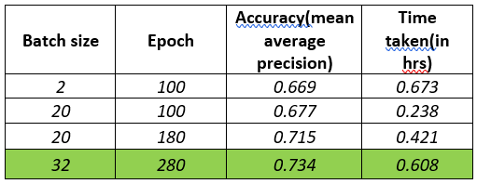

Fig. 4. Example Output from YOLOv5 Model

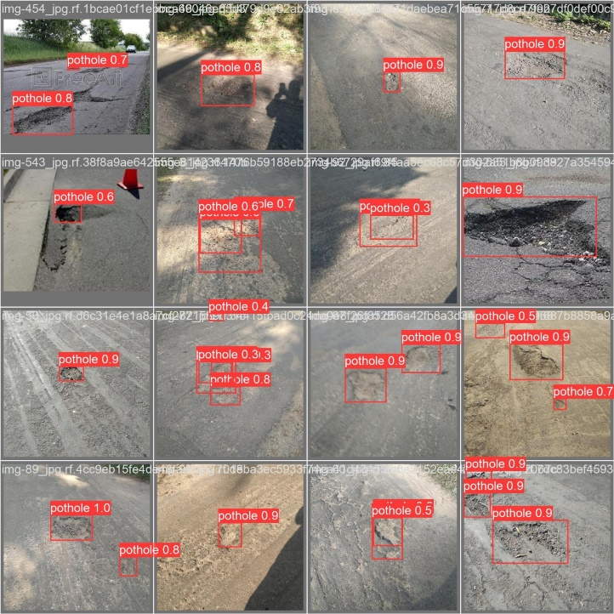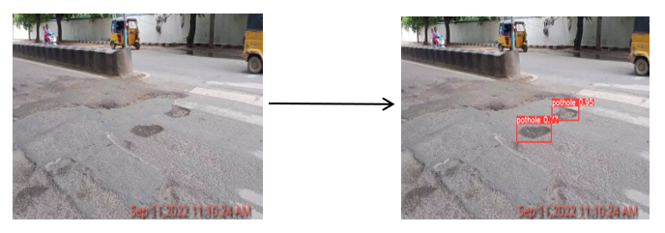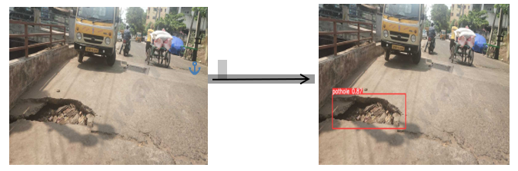

Fig. 5. Output from the YOLOv5 Model

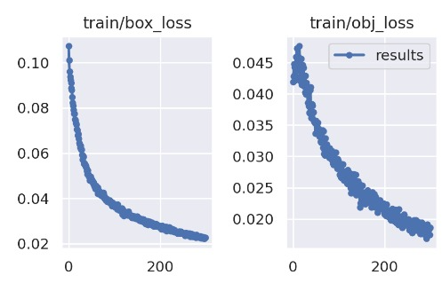

Fig. 6. Object loss function for Training

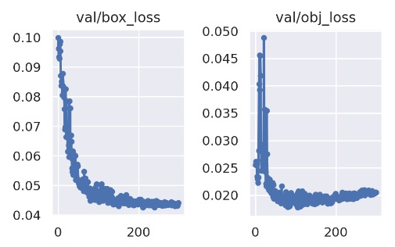

Fig. 7. Object loss function for Validation

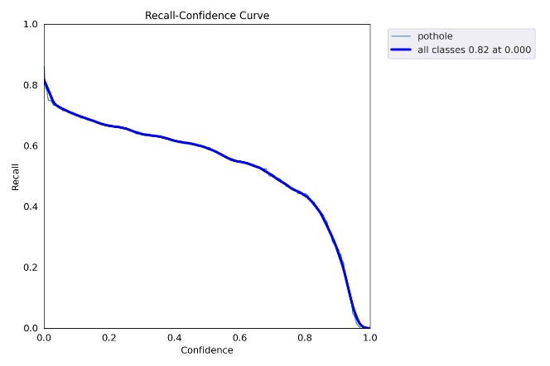

Fig. 8. Recall Confidence Curve

Fig. 9. Precision Confidence Curve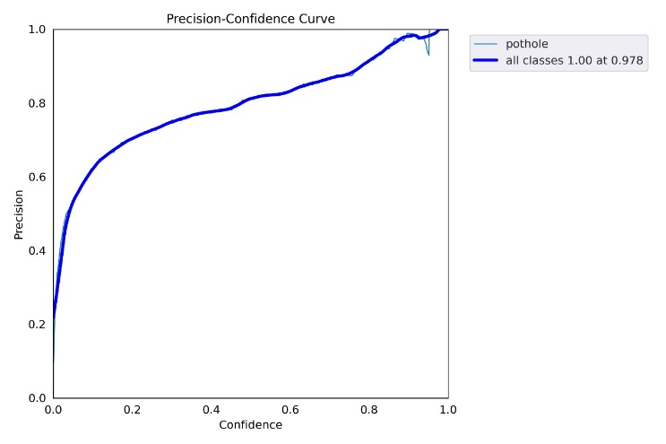

For CNN, the model is trained on different epochs and on different architectures, and the batch size taken was kept default i.e., 32 .

And, the dataset which is used consist total of 960 images of data, out of which 486 are of plain images and 474 are of pothole images.

While forwarding the data to the model for training, the dataset was split into two parts train and test in 80:20 ratio.

Therefore 768 image data was passed to the model for training and 192 image data was kept for testing.

The accuracy for CNN comes out to be 93.34%.

# Conclusion

The identification of various deep learning techniques for detecting the potholes was done and then the accuracy obtained from various models is compared to obtain the best model with the highest accuracy. The CNN algorithm was preferred over YOLO v5 algorithm as CNN algorithm gave 93.34% accuracy were as YOLO v5 algorithm gave 73.34% accuracy. Further the accuracy of the YOLO v5 algorithm can be increased by training the model using a large volume of training dataset. The best model obtained can be used in future for various other applications. Further, my future work would be implementing this model in real world environment in which an camera placed in an vehicle can be used to collect live data and then performing live processing of the data and then using the results to design an application in which the location of the damaged roads can be mapped and the same images can be shown on the map.

##### References

1. Pandey, Anup Kumar, Rahat Iqbal, Tomasz Maniak, Charalampos Karyotis, Stephen Akuma, and Vasile Palade. "Convolution neural networks for pothole detection of critical road infrastructure." Computers and Electrical Engineering 99 (2022): 107725.
2. Dewangan, Deepak Kumar, and Satya Prakash Sahu. "PotNet: Pothole detection for autonomous vehicle system using convolutional neural network." Electronics Letters 57, no. 2 (2021): 53-56.
3. Yuan, Yuan, Lei Chen, Huarui Wu, and Lin Li. "Advanced agricultural disease image recognition technologies: A review." Information Processing in Agriculture (2021).
4. Ma, Nachuan, Jiahe Fan, Wenshuo Wang, Jin Wu, Yu Jiang, Lihua Xie, and Rui Fan. "Computer vision for road imaging and pothole detection: a state-of-the-art review of systems and algorithms." Transportation safety and Environment 4, no. 4 (2022): tdac026.
5. Mukherjee, Ratnajit, Haris Iqbal, Shabbir Marzban, Ahmed Badar, Terence Brouns, Shruthi Gowda, Elahe Arani, and Bahram Zonooz. "AI Driven Road Maintenance Inspection." arXiv preprint arXiv:2106.02567 (2021).
6. Dharneeshkar, J., S. A. Aniruthan, R. Karthika, and Latha Parameswaran. "Deep Learning based Detection of potholes in Indian roads using YOLO." In 2020 international conference on inventive computation technologies (ICICT), pp. 381-385. IEEE, 2020.
7. Kang, Byeong-ho, and Su-il Choi. "Pothole detection system using 2D LiDAR and camera." In 2017 ninth international conference on ubiquitous and future networks (ICUFN), pp. 744-746. IEEE, 2017..
8. Kavitha, R., and S. Nivetha. "Pothole and object detection for an autonomous vehicle using yolo." In 2021 5th International Conference on Intelligent Computing and Control Systems (ICICCS), pp. 1585-1589. IEEE, 2021.
9. Vigneshwar, K., and B. Hema Kumar. "Detection and counting of pothole using image processing techniques." In 2016 IEEE International Conference on Computational Intelligence and Computing Research (ICCIC), pp. 1-4. IEEE, 2016.
10. Deepa, D., and A. Sivasangari. "An effective detection and classification of road damages using hybrid deep learning framework." Multimedia Tools and Applications (2022): 1-34.
11. Chitale, Pranjal A., Kaustubh Y. Kekre, Hrishikesh R. Shenai, Ruhina Karani, and Jay P. Gala. "Pothole detection and dimension estimation system using deep learning (yolo) and image processing." In 2020 35th International Conference on Image and Vision Computing New Zealand (IVCNZ), pp. 1-6. IEEE, 2020.
12. Deepa, D., R. Vignesh, A. Sivasangari, Suja Cherukullapurath Mana, B. Keerthi Samhitha, and Jithina Jose. "Visualizing road damage by monitoring system in cloud." International Journal of Electrical Engineering and Technology 11, no. 4 (2020): 191-203.
13. Fang, Yiming, Xianxin Guo, Kun Chen, Zhu Zhou, and Qing Ye. "Accurate and Automated Detection of Surface Knots on Sawn Timbers Using YOLO-V5 Model." BioResources 16, no. 3 (2021).
14. Pathak, Ajeet Ram, Manjusha Pandey, and Siddharth Rautaray. "Application of deep learning for object detection." Procedia computer science 132 (2018): 1706-1717.
15. Song, Hyunwoo, Kihoon Baek, and Yungcheol Byun. "Pothole detection using machine learning." Advanced Science and Technology (2018): 151-155.